Task: Frozen Drama | Teacher:
Explanation of Task: Work with others to retell a story using Freeze Frames.

Student Name: | Overall Grade:

Criteria  Drama | Uni-structural   | Multi-structural   | Relational   | Extended Abstract  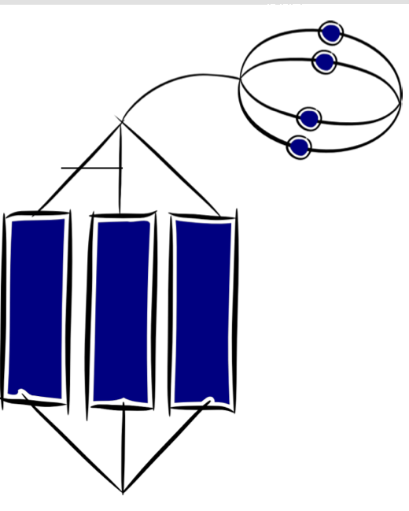
Developing practical knowledge  Elements of place, role, events & situation.  Being part of a Freeze Frame | With support I can name the characters in the story and say where they live.  I struggled to stand still long enough when being part of the group Freeze Frame picture. | I can say who the characters are and where they live.  With some support I can say how the characters are feeling.  I was able to stand still long enough when being part of the group Freeze Frame picture.  I tried to show how my character felt. | I can say who the characters are, how they feel, where they live and talk about some of the things that they do in the story.  I was able to stand still long enough when being part of the group Freeze Frame picture.  I could show how my character felt. | I can say who the characters are, where they live and what they are doing in the story.  With support I can place the events in the story in order.  I was able to stand still long enough when being part of the group Freeze Frame picture.  I could show how my character felt and what they were doing..
Developing ideas  Using personal experience and imagination | With support I can share and use ideas from my personal experience for a drama. | I can share ideas from my personal experience for a drama.  With some support I can use my imagination for ideas to share for a drama. | I can share ideas from my personal experience and imagination for a drama. | I can share ideas from my personal experience and imagination for a drama.  With some support I can use my personal experience and imaginative ideas together.
English | Uni-structural | Multi-structural | Relational | Extended Abstract
Listen, Reading, Viewing  Recognise and identify ideas within and across texts | With support I can name the characters in the story and where they live | I can say who the characters are and where they live.  With some support I can say how the characters are feeling. | I can say who the characters are, how they feel, where they live and talk about some of the things that they do in the story. | I can say who the characters are, where they live and what they are doing in the story.  With support I can place the events in the story in order.

