**Drama - Understand in context, develop character**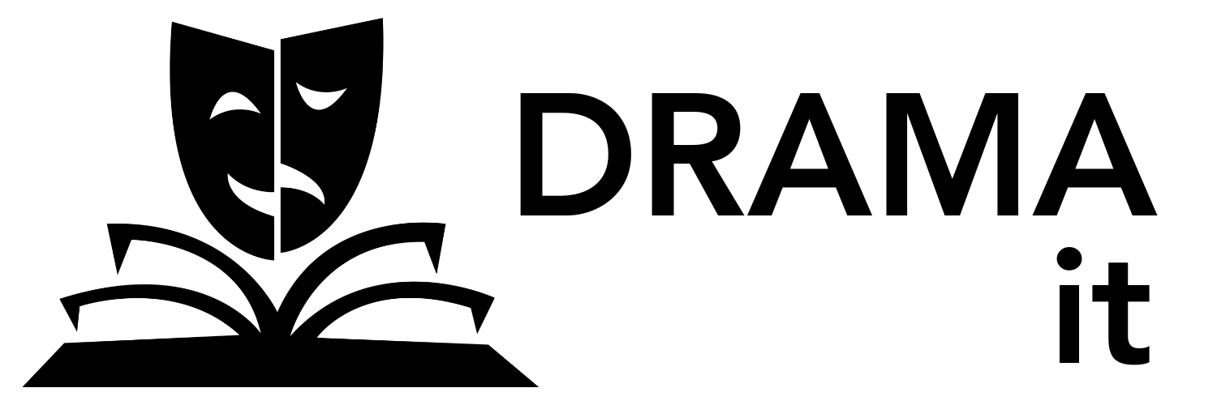

**English - Find, interpret and write**

**Art - Develop, create and explain**

| **Student Name:** | **Overall Grade:** |
| --- | --- |

| **Criteria**  **DRAMA** | **Emerging/**  **Basic/Achieved** | | **Developed/Proficient/Merit** | | **Skilled/Advanced/Excellence** |
| --- | --- | --- | --- | --- | --- |
| **Understanding the task** | I understood most of the task.  I will ask for help when I need it. | | I understood the task.  I will ask for help and sometimes help others. | | I understood the task.  I can ask for help and help others. |
| **Understanding Drama in context**  **The use of mask/prop/costume/**  **lighting in Drama** | I was able to identify and understand some ideas about the use of mask/prop/costume/lighting in Drama and/or cultures. | | I was able to identify, explain and compare ideas about the purpose of mask/prop/costume/lighting in Drama and/or cultures.  I included images with some notes to help explain my understanding. | | I was able to identify, explain, compare and evaluate ideas about the purpose of mask/prop/costume/lighting in Drama and/or cultures.  I included images with good notes and captions to enhance the communication of my understanding. |
| **Developing my idea** | I was able to identify how I wanted my example/item to look, but struggled to develop my ideas to reflect this. | | I was able to combine and compare ideas from the play/information/images, with my own ideas to create my example/item.  I could explain the decisions I made. | | I was able to evaluate and modify my decisions, relating them back to the play/information/images and my original ideas. |

| **Criteria**  **ENGLISH** | **Emerging/**  **Basic/Achieved** | | **Developed/Proficient/Merit** | | **Skilled/Advanced/Excellence** |
| --- | --- | --- | --- | --- | --- |
| **Ideas from given text (paper)**  **Ideas from a website** | I understood ideas in the play/information I read and made some decisions for my  example/item based on this.  I found some information but did not really understand it. | | I identified and linked ideas from within the play/information I read to help me search for images/information to extend my thinking.  I identified, interpreted and combined ideas to explain the use of mask/prop/costume/lighting in Drama and/or cultures. | | I identified, linked and evaluated ideas from within the play/information I read to help me search for imagesinformation to extend my thinking.  I identified, interpreted and evaluated ideas before combining them to explain the use of mask/prop/costume/lighting in Drama and/or cultures. |
| **Writing about the use of mask/prop/costume/**  **lighting in Drama.** | I struggled to rewrite the information in my own words. There were some words I did not understand.  The images were not always relevant. | | I rewrote my information, explaining it clearly and integrating technical words related to the topic.  Images were used with a clear purpose. | | I rewrote my information, explaining and combining ideas, while integrating technical words related to the topic.  Images were used with a clear purpose. |
| **Writing about my ideas** | I could write about the ideas I had on mask/prop/costume/lighting but struggled to make links to the play/information I had read. | | I explained my ideas on mask/prop/costume/lighting, making clear links to the play/information I read and the images I found. | | I explained what and why my mask/prop/costume/lighting, evaluating and making clear links to the play/information I read and the images I found. |

| **Criteria**  **ART** | **Emerging/**  **Basic/Achieved** | | **Developed/Proficient/Merit** | | **Skilled/Advanced/Excellence** |
| --- | --- | --- | --- | --- | --- |
| **Develop and revisit ideas** | I struggled to select ideas from the play/information/images to develop a design.  I did not want to sketch more than one idea. | | I identified and combined ideas from the play/information/images and multiple related images to develop a design.  I sketched at least three different ideas, often combining aspects from my previous designs. | | I identified, combined and evaluated ideas from the play/information/images and multiple related images to develop a design.  I sketched more than four different ideas, combining and reflecting on aspects from my previous designs. |
| **Select and use appropriate materials** | I needed help to create a list of materials I needed.  The end product was different from the designed example/item. | | I identified, listed and revisited my materials list throughout the process.  I selected and used a variety of materials to add texture, shape and/or colour to produce my designed example/item. | | I identified, listed and revisited my materials list throughout the process, evaluating their effectiveness..  I selected and used a variety of materials to add texture, shape and colour to produce my designed example/item |
| **Explain my ideas** | I needed help to explain the design decisions I had made.  I needed help to explain why I used certain materials. | | I identified and made links to the play/information/images while explaining my design ideas.  I related the use of certain materials to the look and/or what I was trying to express with my example/item. | | I identified and made strong links to the play/information/images while explaining my design ideas.  I related the use of certain materials to the look I was trying to express with my example/item.  . |